Visualising Natural Disaster Image Embeddings

January 2026
By
Rashid Ahmed Pandor
Student number: 202302628

Word count: 1858

Table of Contents
1. Project Overview 3
1.1 Context and Rationale 3
1.2 Project Aims 3
1.3 Objectives 3
2. Summary of Progress 4
2.1 Development Environment & Pipeline Architecture 4
2.2 Data Ingestion 5
2.3 Prototype V4 - Data Validation Layer 8
2.4 Technical challenges and Solutions 10
3. Updated Project Plan 10
3.1 Commentary on Plan Changes 12
3.2 Future Milestones 13
3.3 Resource and Risk Management 13
3.4 Data Ethics and Compliance 13
References: 14

1. Project Overview

1.1 Context and Rationale
When a major crisis happens, emergency authorities and workers were flooded with so much data. Social networking websites are flooded with millions of photographs and text messages, evidently providing real time information about the situation. But however, suggested in the analysis of the study on the CrisisMDD dataset, the straight problem with the massive influx of unstructured information is its suitability for average human processing. This type of bottleneck is important because humanitarian responders can’t physically process information quickly to maintain situational awareness. Current technology depends on Supervised machine learning classification where pre-existing categories are made for example, “Fire”. It would fail to identify a disaster event if the model hasn’t been trained well to recognise it. My project will also implement a zero shot learning pipeline using CLIP and UMAP for a better approach of unsupervised, semantic exploration of the dataset.

My project is to overcome the requirements of pre-defined labels in the images. It uses the Contrastive Language-Image Pre-training (CLIP) approach that shows the semantic meaning of the disaster images to be determined without the use of labelled images. When Uniform Manifold Approximation and Projection (UMAP) is used in the project the “Global structure” of the dataset can be shown.

1.2 Project Aims
My project’s aim is to develop an interactive visualisation for unsupervised exploration of the CrisisMDD dataset. My system would show the visualisation of semantic relationships in thousands of disaster images and enable semantic searches using natural language phrases in a zero-shot method.

1.3 Objectives
For my project these are the technical goals I will aim to achieve:
Data Pipeline - Develop a robust data ingestion pipeline that would clean and process the multimodal metadata features of images in the CrisisMDD dataset ~18,000 images.
Feature Extraction - To create an offline vectorisation procedure via the CLIP model to transform disaster images into high-dimensional feature representations.
Projection - Using UMAP algorithms for lowering the dimensionality of these vectors from high dimensions into the 2D coordinate space, while preserving the global structure of disaster clusters.
Visualisation - Develop an interactive web dashboard capable of displaying these coordinates. Interactive aspects would include real time filtering and Semantic Search.
Evaluation - Evaluating the quality of the clusters created by the use of objective criteria such as Silhouette Scores and user evaluation.

2. Summary of Progress
I would say that I am on schedule as far as the development is concerned. I am currently working on intermediate stage of “Phase 2: Core Development” focusing on validation and data ingestion. I will talk about my technical progress made so far here.

2.1 Development Environment & Pipeline Architecture
My focus in the beginning was on setting up an efficient local environment for development. I chose VS Code as the main IDE and structured the code into a standard form that distinguishes between the backend processing and frontend functionality for the data. The main dependencies focus on Dash for the UI and PIL for image processing and you can see this in the image just below here.

Not just that I have also developed the system using the “Offline-Online” architecture. My reason to why I chose this architecture is that it can fix the latency problem in my project when processing around 18,000 images in real time which will be a huge benefit for my project.
Offline: Heavy computations mostly because of vectorisation via CLIP would be performed once, creating a static file containing coordinates.
Online: The Dash application will only read the above said light file during runtime.

It directly links to the scalability needed of being able to process about 18,000 images without ruining the website. I have pasted in an image that currently shows the dynamic image loading process just underneath here.

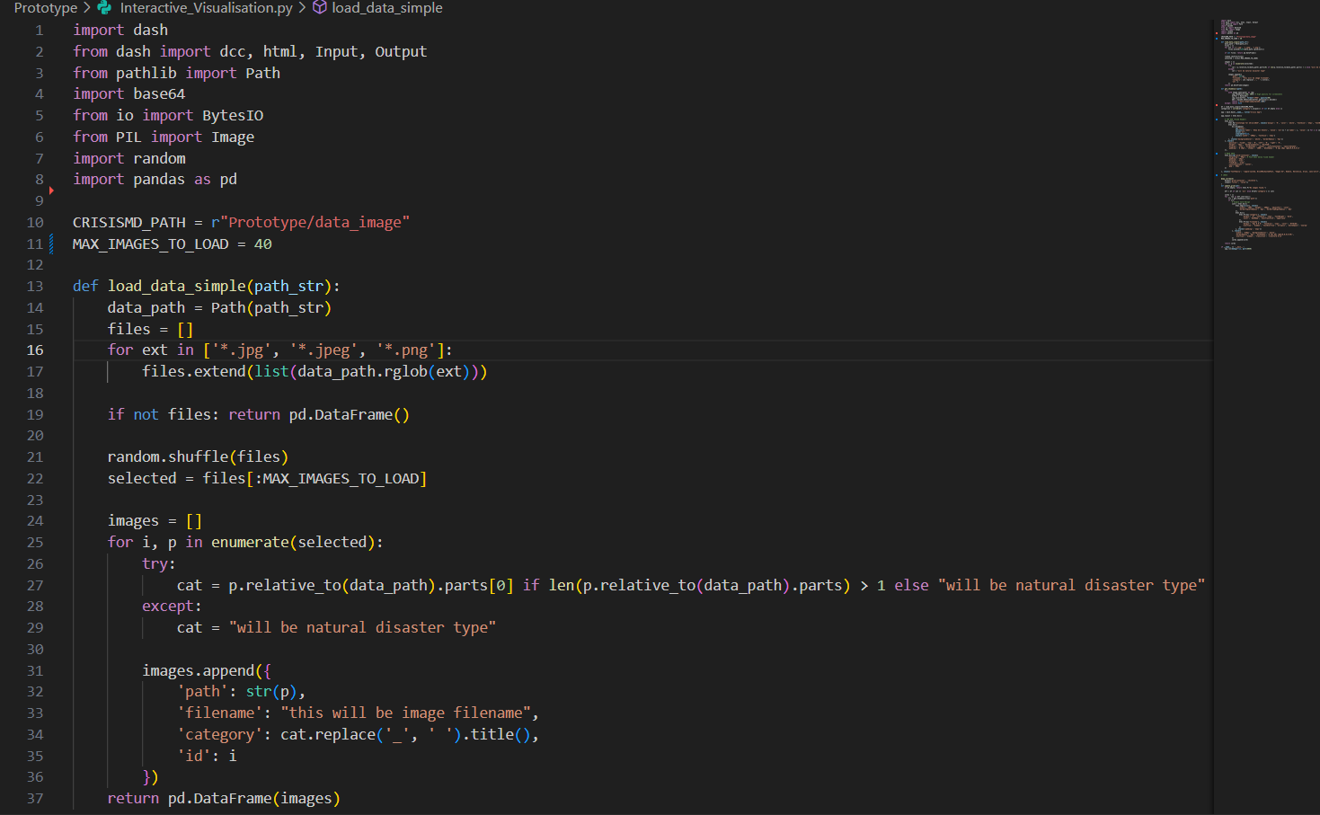
Image 1 shows a Python script made for ingesting data for early prototype which I presented to my supervisor. This outputs the selected images from the data folder and loads them on the web.

2.2 Data Ingestion
The CrisisMMD dataset is very large and has gigabytes of image data as well as text files distributed. Data ingestion became my first major technical problem. So to fix this, I developed a script that parsed a directory format to associate an image with its respective event type for example “California Wildfires” or “Iraq Floods”.

The data is now fully available in the project directory which can be seen in the image below. The error handling mechanism in the ingestion process had to be triggered to automatically skip past the corrupted image files which often come with raw social media data. The “data cleaning” process here was critical because if the corrupted images been passed along to the CLIP model, it would have crashed the entire training process.
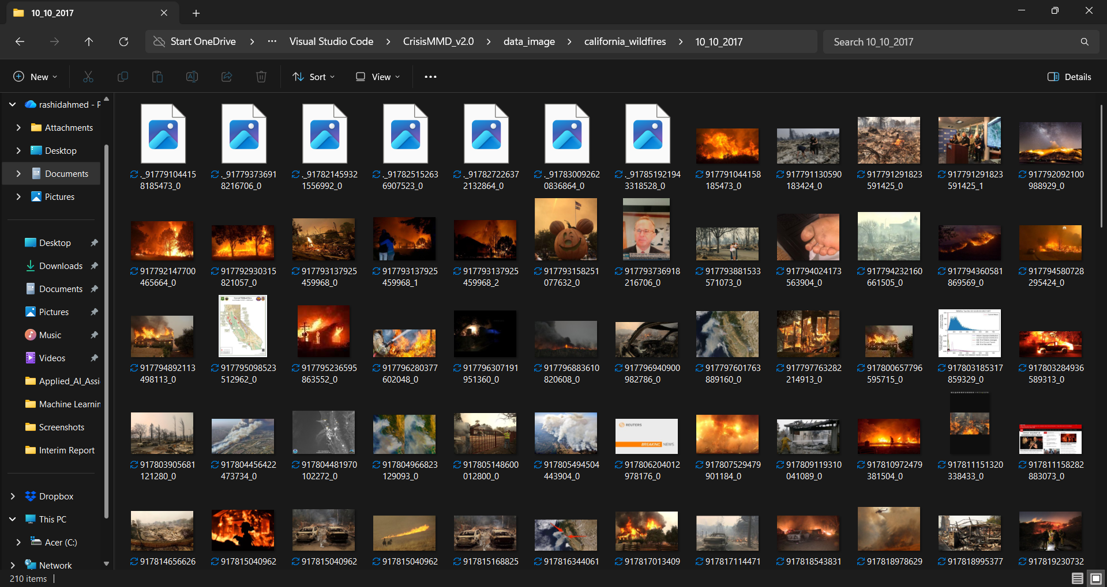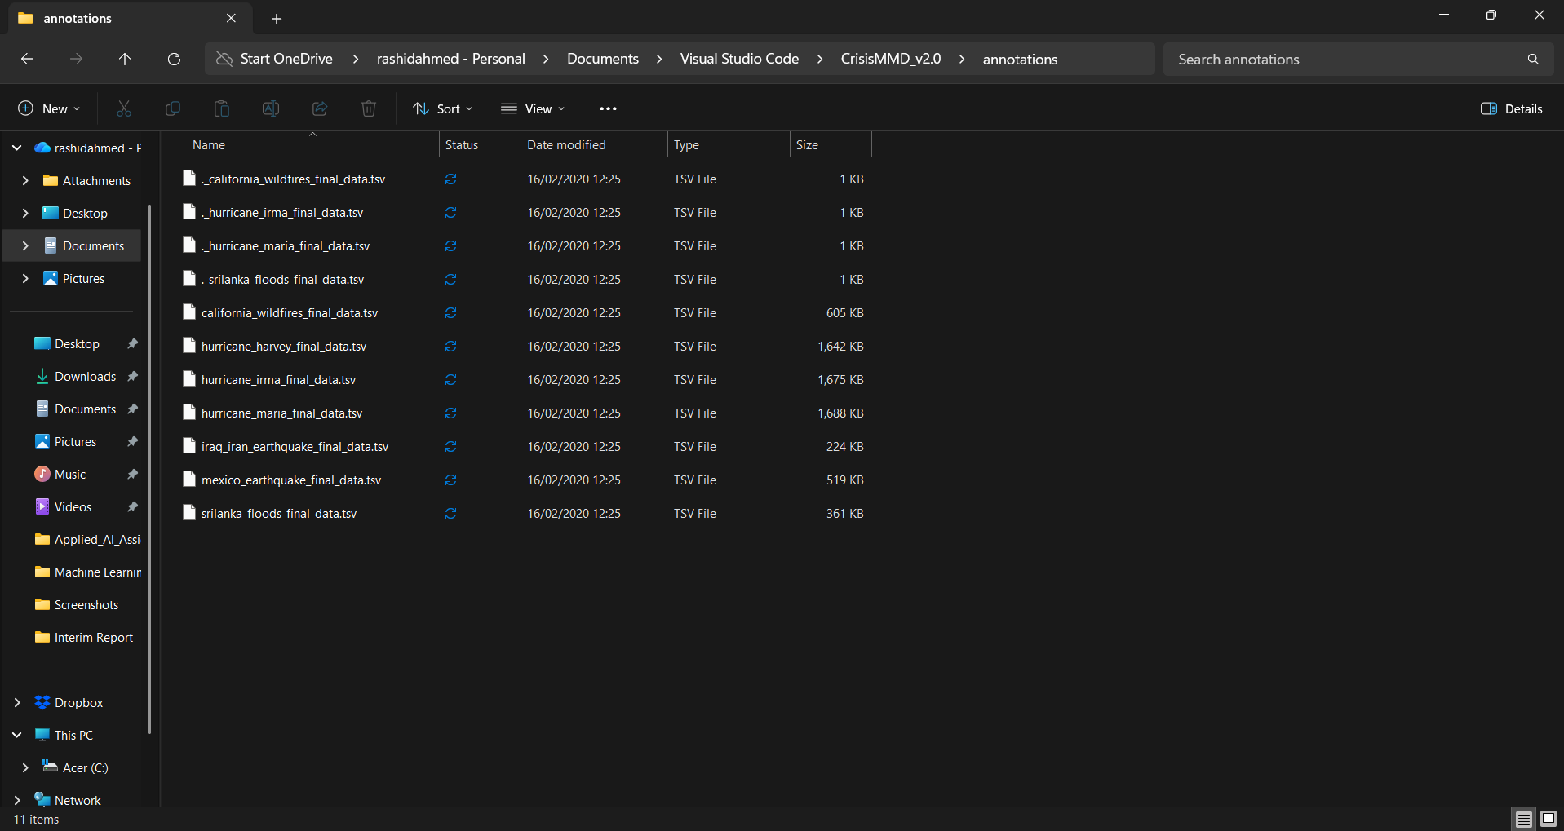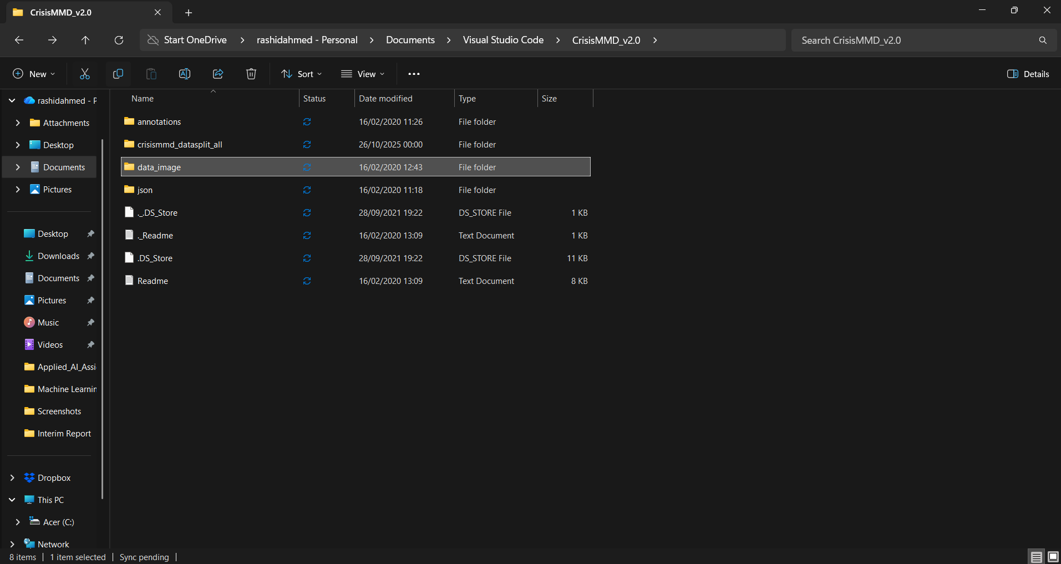
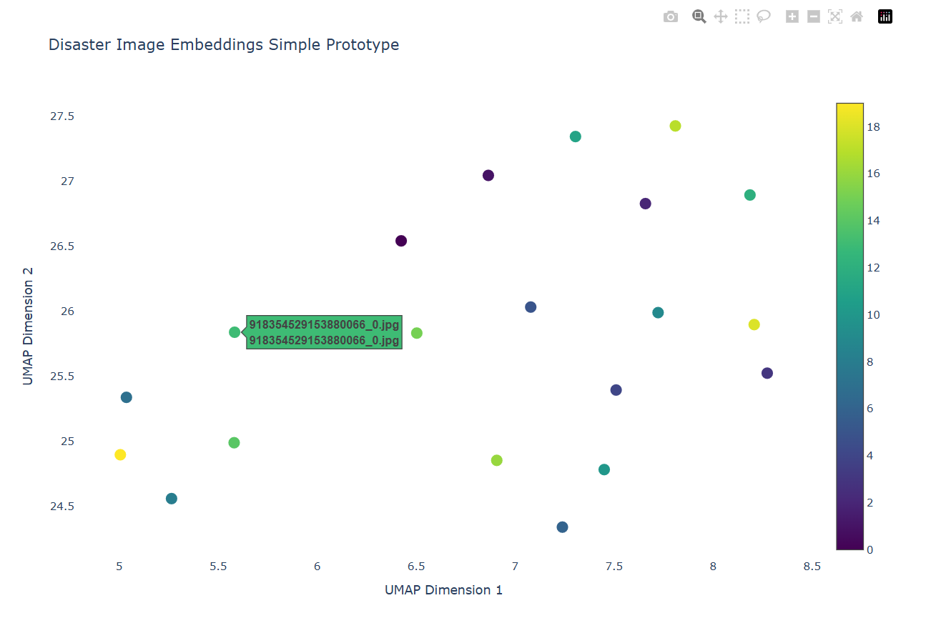
These four images show raw CrisisMMD dataset Ingestion. From top to bottom, image 2 shows the data inside the “California_Wildfire”, Image 3 shows the root directory and some .tsv folders inside annotations folder and images from the “California_Wildfires” folder. Image 4 shows what the root of the dataset looks like and how it’s structured. Image 5 shows a plotted results of a few images measuring their UMAP scores.

2.3 Prototype V4 - Data Validation Layer
I wanted to make sure that the labels were in good condition before creating the UMAP scatter plot. But to get this I created a different prototype which I showed to my supervisor for feedback which is the grid-based explorer tool.

You can see my prototype that is live with a mobile formatted layout in the image below. This lets me filter images for their event type for example “Flood” and see if they match their description visually. This might seem like an easy task but this is an important aspect of Quality Assurance. What I mean is that I noticed that some images that were supposed to be “Infrastructure Damage” were only blurry shots of the ground and other irrelevant images. This data lets me adjust the parameters in my model later on for addressing noisy inputs after. This also shows that the Dash library is capable of rendering images dynamically on any screen size.

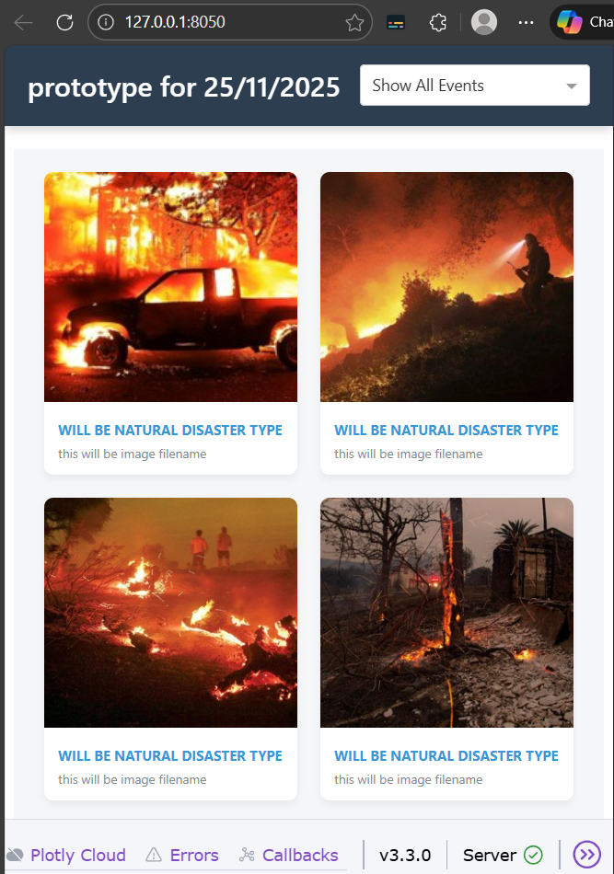
Image 6 shows my early prototype in mobile browser view. This is the interface that enables the live validation of the dataset's metadata prior to vectorisation.

2.4 Technical challenges and Solutions
Whilst I was developing my prototype in phase 2, I found out that my dataset files had some problems that are not critical but important enough for me to figure out what needed to be done first. I thought I was going to be working with image files that also had JSON labels for each picture. I found that 5% of the files had inconsistent names or were missing file extensions after the ingestion script.

So for me to get rid of this problem I had with the dataset, I used a try-except-logging code block in the Python ingest loop. This was a better approach as I didn’t need to stop the entire pipeline because some files were missing but the script will instead print the error id to a new .log file in my repository. This will make sure the integrity of the dataset was preserved and the vectorisation step will not be halted by some issues of file integrity and not just that it also makes it a robust ingestion pipeline which is capable of fixing messy data straight from the internet a huge requirement for a good crisis tool which is very important for something like this. This showed me the usefulness of defensive programming while working with unstructured social media information.

3. Updated Project Plan
I have analysed and checked what remains of the project schedule after finishing off the data ingestion and validation prototype from phase 2. The image I have pasted in shows my updated Gannt chart of the second trimester of this project that spans from January 2026 until April of the same year.

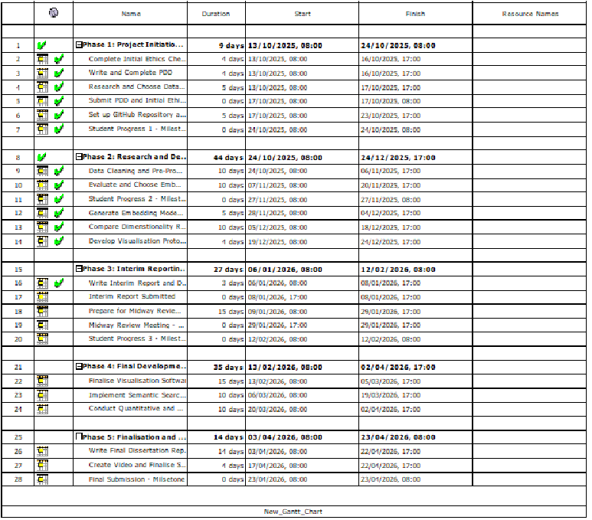
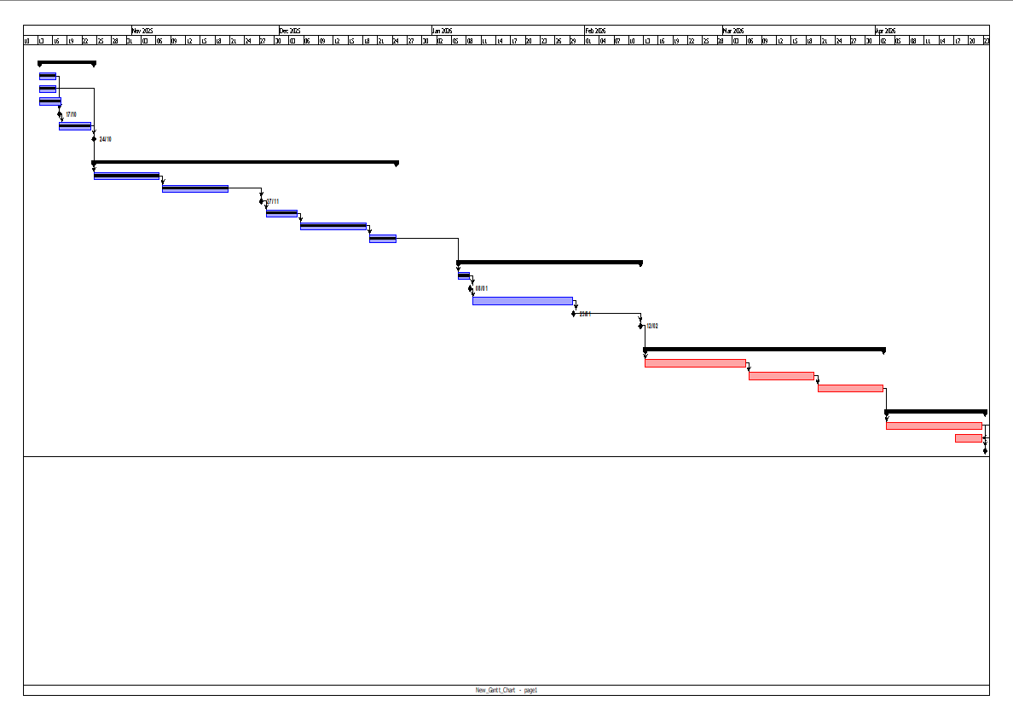

Images 7 and 8 above show my new project schedule using the open source software “Project Libre” to generate a Gantt chart. This has been updated to reflect a prioritising schedule focusing on Semantic search/algorithmic complexity rather than cosmetic accessory.

3.1 Commentary on Plan Changes
One of the most important differences that has happened since my original Project Definition Document is that “3D geospatial Globe Visualisation” has been taken out of my scope for Phase 4.

When I started to think deeply about how I was going to develop a 3D globe that would enable the mapping of disaster photos by geographic location, I identified the following aspects while starting to prototype the development for it:

Data Limitations: The CrisisMMD has areas which are lacking the exact location, such that the world could have been quite thinly populated.

Resource Allocations: Creating a complex 3D web interface can be very expensive computing-wise but intellectually small, since it will require large work by the use of JavaScript without having any “Artificial Intelligence” input to the project.

So because of this I have decided to dedicate that time to enhancing Semantic Search functionality. Instead of simply displaying where a photograph was taken, my project will instead now concentrate on what is present within that photograph. This approach will identify the multimodal aspect of the CLIP model, helping me to deliver natural search functionality by search term for example “People need rescue”, which is more technically demanding than my original approach as it meets more of the best criteria for an AI Research project.

3.2 Future Milestones
My new plan for this research project is to focus on this “Offline-Online” pipeline:
January (Phase 3): I will complete the entire process for vectorisation offline. This will push all 18,000 images through the CLIP encoder, creating the .npy coordinate files.
February (Phase 4): The UMAP dimensionality reduction technique will be used to project the above vectors into a 2D embedding and will be incorporated into the Dash frontend.
March (Phase 5): My work will include the quantitative analysis (Silhouette Scores) and write up.

3.3 Resource and Risk Management
I have made a workflow pattern inspired by the “sprint” approach to make sure I stay on track for the deadline. I’ve chosen to work on a very strict one week cycle. This helps me identify large failure points early in the phase, for example like inconsistencies in metadata in Phase 2 and prevent small data problems, like the ones I’ve came across in Phase 1 by adding up to blocking points in the vectorisation phase. This would involve cloud migration of the new “vectorise.py” file.

3.4 Data Ethics and Compliance
When it comes to managing the data properly in a professional way, I have put a firm ethical standards when using the CrisisMMD dataset. The dataset does include sensitive images due to a variety of humanitarian crises images. I have made sure that the dataset is kept in a local environment that is secure which can be seen in the file explorer image and that isn’t shared. My visualisation will be blurred by default for sensitive images to make sure that the images are treated within ethical terms.

References:
Andrienko, G., Andrienko, N., Jankowski, P., Keim, D., Kraak, M. ‐J., MacEachren, A. and Wrobel, S. (2007). Geovisual analytics for spatial decision support: Setting the research agenda. International Journal of Geographical Information Science, 21(8), pp.839–857. doi: https://doi.org/10.1080/13658810701349011.
Alam, F., Ofli, F. and Imran, M. (2018) “CrisisMMD: Multimodal Twitter Datasets from Natural Disasters”, Proceedings of the International AAAI Conference on Web and Social Media, 12(1). doi: 10.1609/icwsm.v12i1.14983 [Accessed 29 Dec. 2025].
McInnes, L., Healy, J. and Melville, J. (2018). UMAP: Uniform Manifold Approximation and Projection for Dimension Reduction. [online] arXiv.org. Available at: https://arxiv.org/abs/1802.0342 [Accessed 29 Dec. 2025].
Ofli, F., Alam, F. and Imran, M. (2020). Analysis of Social Media Data using Multimodal Deep Learning for Disaster Response. [online] arXiv.org. Available at: https://arxiv.org/abs/2004.11838 [Accessed 30 Dec. 2025].
Radford, A., Kim, J.W., Hallacy, C., Ramesh, A., Goh, G., Agarwal, S., Sastry, G., Askell, A., Mishkin, P., Clark, J., Krueger, G. and Sutskever, I. (2021b). Learning Transferable Visual Models From Natural Language Supervision. [online] proceedings.mlr.press. Available at: https://proceedings.mlr.press/v139/radford21a [Accessed 30 Dec. 2025].
Castillo, C., 2016. Big crisis data: social media in disasters and time-critical situations. Cambridge University Press.
Imran, M., Castillo, C., Diaz, F. and Vieweg, S., 2015. Processing social media messages in mass emergency: A survey. ACM computing surveys (CSUR), 47(4), pp.1-38.
Liu, S., Palen, L., Sutton, J., Hughes, A. and Vieweg, S. (2008). On-Line Photo Sharing in Times of Disaster In Search of the Bigger Picture: The Emergent Role of On-Line Photo Sharing in Times of Disaster. [online] Available at: https://ics.uci.edu/~ucrec/pubs/upload/919_Liu2010.pdf [Accessed 23 Dec. 2025].
Nguyen, D.T., Ofli, F., Imran, M. and Mitra, P., 2017, July. Damage assessment from social media imagery data during disasters. In Proceedings of the 2017 IEEE/ACM international conference on advances in social networks analysis and mining 2017 (pp. 569-576).
Voulodimos, A., Doulamis, N., Doulamis, A. and Protopapadakis, E. (2018). Deep Learning for Computer Vision: a Brief Review. Computational Intelligence and Neuroscience, 2018(1), pp.1–13. doi: https://doi.org/10.1155/2018/7068349

